FMA Demersal macroalgal feeders Ocean perch, Yellow eye mullet, Latchet

**Ocean perch *Helicolenus barathri*** 250 - 800 m***, H.*** percoides (80 m and 350 m)

By %IRI, pelagic tunicates (salps) were the most important prey item, with the two-spined crab (Pycnoplax victoriensis) being the second most important item, and fish, most frequently identified as macrourids, being the third. Scampi (Metanephrops challengeri) were important prey in terms of weight, but being relatively infrequent had a %IRI value an order of magnitude less than the former categories. Isopods, mainly the spiny serolid Acutiserolis sp.,

were recorded frequently and had the fourth highest %IRI, but made only a small contribution by weight. Helicolenus percoides was found to target the two-spined crab (Pycnoplax victoriensis) and salps, but with the dominant prey species varying with location on the Chatham Rise, and with predator size. Other crustaceans, particularly scampi (Metanephrops challengeri), serolid isopods (Acutiserolis sp.), and galatheids (Munida sp.),

and fishes (primarily macrourids), were also important prey items. Blaber & Bulman (1987) found that salps and fish (particularly myctophids) dominated the H. percoides diet off eastern Tasmania, with crabs, galatheids, and brittle stars being of moderate importance. This diet has some similarity to the current study, which found that salps and crabs were the main dietary components but fish was less important. In an area about 300 km north of Chatham Rise, Jones (2009) found that natant decapod prawns and the crab Pycnoplax victoriensis were the most important food for H. percoides, fish and salps were moderately important, and minor components were similar to the current study. These studies demonstrate some variability, but show that H. percoides is a persistent benthic forager. For H. percoides, the diet shift with increasing predator size was from smaller crustaceans (mysids and galatheids) to larger crustaceans (scampi and the two-spined crab), a pattern also found by Jones (2009).

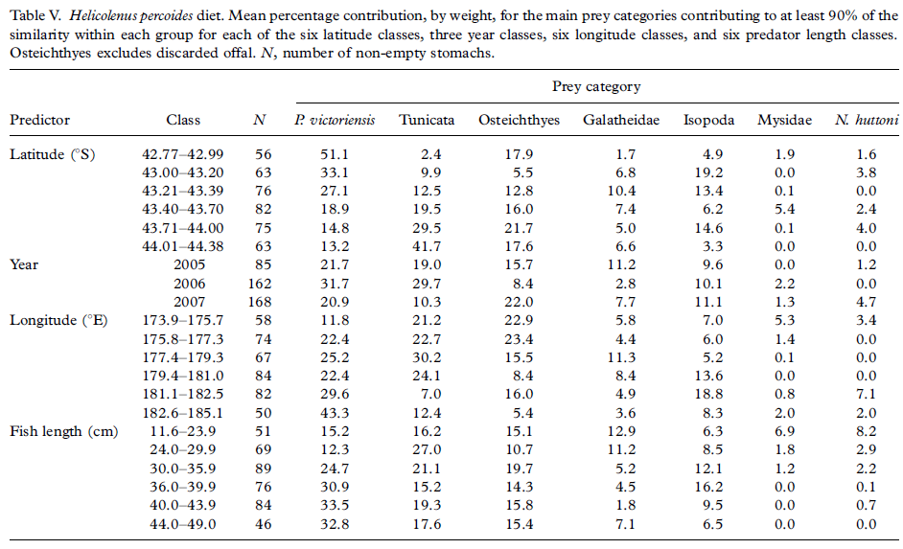

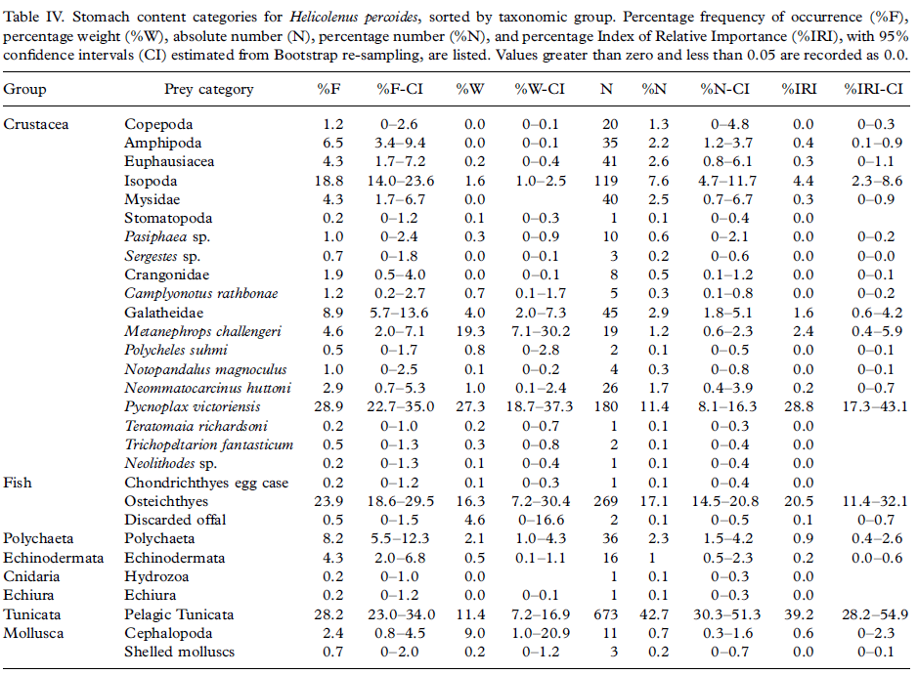

**Yelloweye mullet (**Aldrichetta forsteri) feeds on detritus and plankton

Polychaetes and coarse organic material were ingested by all but the smallest individuals of A. forsteri [Fig. 2(b)]. Insects (collembolans and hymenopterans) and small crustaceans (copepods and gammarid amphipods), however, dominated the diet of individuals of this mugilid <125 mm LT, and particularly of those <75 mm, and mytilids (Xenostrobus spp.) were found only in the gut contents of the three size classes <175 mm [Fig. 2(b)]. In contrast, large crustaceans (P. australis) were ingested only by individuals of A. forsteri >225 mm. Wide range of food items ingested by this mugilid, which included diatoms, plant material, polychaetes, neogastropod molluscs, several major crustacean groups and insects, as well as coarse organic material and detritus. diet of M. cephalus did not change with body size, it is important to recognize that the smallest individual of this species caught in Wilson Inlet was 75 mm.

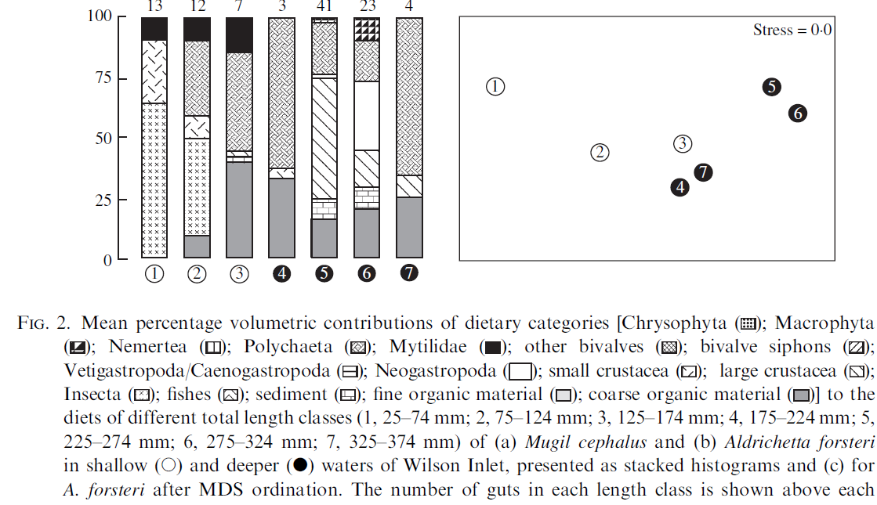

Little Weed Whiting, *Neoodax balteatus* no info

Bluespotted Goatfish, *Upeneichthys vlamingii* no info

Sea Mullet, *Mugil cephalus* no info

Goldspot Mullet, *Liza argentea* no info

Diamondscale Mullet, *Liza vaigiensis* no info

Sand Mullet, *Myxus elongatus* no info

**Latchet** *Pterygotrigla polyommata* (Triglidae)– no info

Triglids are typically associated with sandy or muddy substrata, whereas pempheridids have typically been recorded as occurring near, in or on reefs, breakwaters and seagrass. The members of both of these families feed predominantly on epibenthic invertebrates

*Lepidotrigla modesta* and *Lepidotrigla papilio* (Triglids)

The diets of each species contained between 19 and 24 dietary categories. Each of the four species consumed mainly crustaceans, being present in the stomachs of virtually all fish. The contributions of crustaceans to the diets of each species ranged from 92·1 to 97·6% for total numbers of prey and from 72·4 to 95·0% with dietary volume. Polychaetes made appreciable contributions to the volume of the dietary contents of *P. klunzingeri* and *P. elongatus*, i.e. 21·1 and 12·8%, respectively. Molluscs made only a small contribution to the diets of each species, with the greatest contribution to the dietary volume. Teleosts contributed >0·6% to the dietary volume only with *P. klunzingeri*, and even then it was only 1·6%, and the contribution of algae to the dietary volume of each species was always <0·1%. Mysids and cumaceans were by far the most important dietary categories of *L. modesta*, contributing

42·5 and 26·7%, respectively, to the total numbers, and 25·4 and 32·1%, respectively, to the

dietary volume of this species (Table 2). The only other dietary categories that contributed more than 5% to the total numbers of *L. modesta* were gammarid amphipods and carid decapods, which also made substantial contributions to the dietary volume, i.e. 14·9 and 13·0%, respectively. Although mysids and cumaceans were also the most important dietary categories in terms of both numbers and volume in the stomach contents of *L. papilio*, their contributions to the dietary volume of this species, i.e. 20·0 and 18·5%, respectively, were less than for *L. modesta* (Table 2). Flabelliferan isopods, carid decapods, gammarid amphipods and oxyrhyncan crabs contributed 16·2, 11·4, 10·0 and 8·8%, respectively, to the dietary volume of *L. modesta*. No other category contributed more than 6% to the total dietary volume of this triglid (Table 2). In terms of volume, the diets of the smaller individuals of *L. modesta*, i.e. 75–99 mm, comprised mainly cumaceans (36·3%), amphipods (20·8%) and mysids (16·8%), with carid decapods contributing a further 8·0% (Figure 4). These same dietary categories were also the most important in the diets of the next two larger size classes. However, in the case of the largest fish, the diets were dominated by isopods and amphipods, which collectively contributed nearly 70% to the overall dietary volume. In the case of *L. papilio*, nearly 40% of the dietary volume of the smallest size class, i.e. 75–99 mm, comprised mysids, whereas ostracods, cumaceans, amphipods and isopods contributed between 9 and 19%. As this triglid increased in size, the dietary contributions of ostracods and mysids declined progressively until these prey were virtually absent in the diets of the largest fish, i.e. 150–174 mm. In contrast, the contributions of cumaceans and isopods increased with body size, with the result that they collectively contributed nearly 75% of the diets of the largest fish. Carid decapods and crabs made substantial contributions only to the diets of fish of 100–149 mm. The diets of *L. modesta* and *L. papilio* were dominated

by epibenthic crustaceans, such as cumaceans, mysids, gammarid amphipods and carid decapods, these categories collectively comprising *2*85 and 60% of the diets of these two species, respectively. This dominance of the diet by epibenthic crustaceans, which parallels the situation recorded for similar-sized triglids elsewhere (e.g. Ross, 1977; Moreno-Amich,

1996; Morte *et al*., 1997), implies that our two triglid species forage on or just above the substratum surface. Furthermore, the very low contributions made to the diets of these two species by infauna, such as polychaetes and bivalve molluscs, indicate that these triglids do not feed extensively within the substratum, as is the case with members of the Gerreidae, Mullidae and Urolophidae in these same waters.

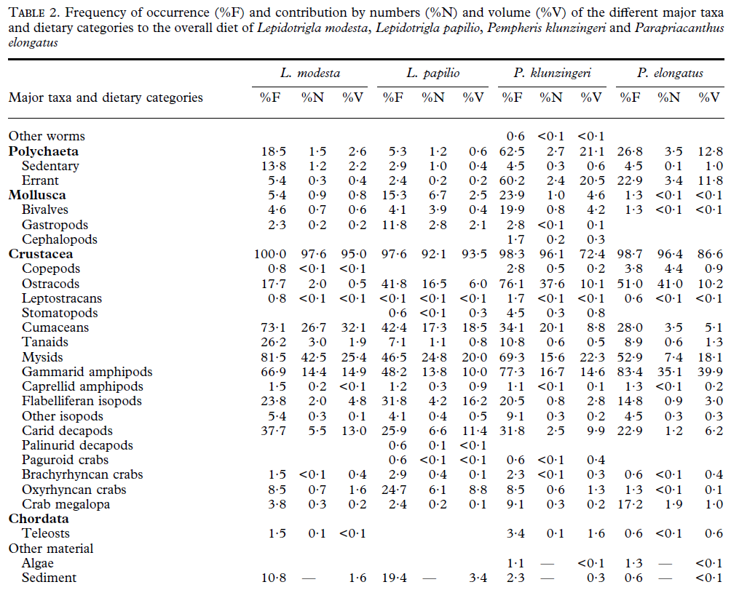

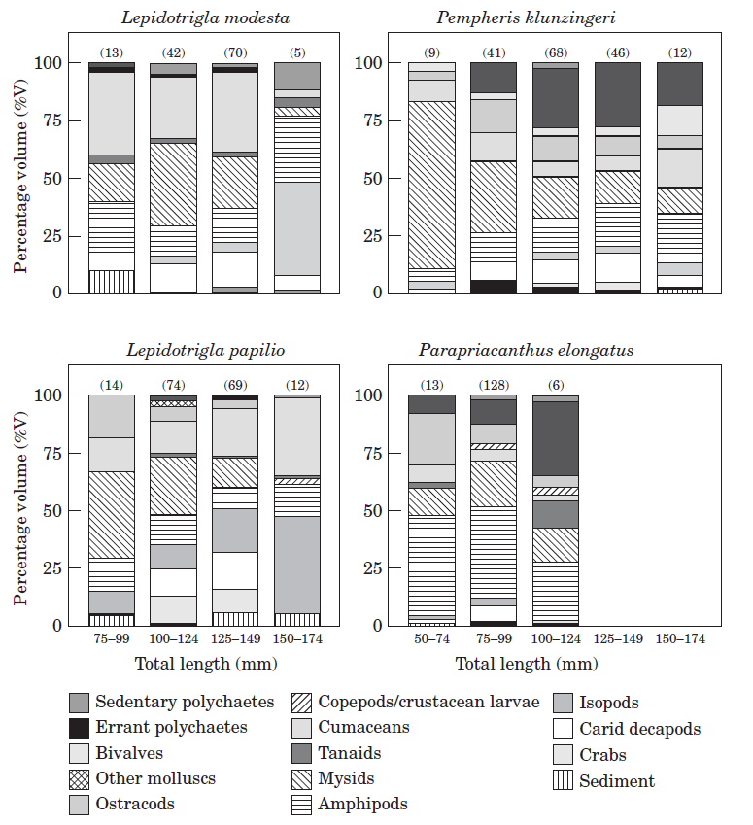

**Ocean perch *Helicolenus barathri***

11.6-23.9 cm

|  |  |
| --- | --- |
| **prey item** | **probability of consuming** |
| MAZ | 0.3 |
| SAL | 0.3 |
| FMP | 0.3 |
| BG | 0.1 |
| BC | 0.1 |
| BD | 0.1 |

24-29.9 cm

|  |  |
| --- | --- |
| **prey item** | **probability of consuming** |
| MAZ | 0.3 |
| SAL | 0.3 |
| FMP | 0.25 |
| BG | 0.15 |
| BC | 0.1 |
| BD | 0.1 |

30-35.9 cm

|  |  |
| --- | --- |
| **prey item** | **probability of consuming** |
| MAZ | 0.3 |
| SAL | 0.2 |
| FMP | 0.3 |
| BG | 0.15 |
| BC | 0.1 |
| BD | 0.1 |

36-39.9 cm

|  |  |
| --- | --- |
| **prey item** | **probability of consuming** |
| MAZ | 0.3 |
| SAL | 0.2 |
| FMP | 0.3 |
| BG | 0.15 |
| BC | 0.1 |
| BD | 0.1 |

40-43.9 cm

|  |  |
| --- | --- |
| **prey item** | **probability of consuming** |
| MAZ | 0.3 |
| SAL | 0.2 |
| FMP | 0.3 |
| BG | 0.15 |
| BC | 0.1 |
| BD | 0.1 |

44-49 cm

|  |  |
| --- | --- |
| **prey item** | **probability of consuming** |
| MAZ | 0.3 |
| SAL | 0.2 |
| FMP | 0.3 |
| BG | 0.15 |
| BC | 0.1 |
| BD | 0.1 |

**Yelloweye mullet**

1.25-74 mm

|  |  |
| --- | --- |
| **prey item** | **probability of consuming** |
| BG | 0.3 |
| ZME | 0.3 |
| BFF | 0.1 |

75-124 mm

|  |  |
| --- | --- |
| **prey item** | **probability of consuming** |
| BC | 0.2 |
| BG | 0.1 |
| ZME | 0.1 |
| BFF | 0.3 |
| BAC | 0.05 |
| DR | 0.05 |
| DL | 0.05 |

125-174 mm

|  |  |
| --- | --- |
| **prey item** | **probability of consuming** |
| BC | 0.3 |
| BG | 0.05 |
| ZME | 0.05 |
| BFF | 0.2 |
| BAC | 0.2 |
| DR | 0.2 |
| DL | 0.2 |

175-224 mm

|  |  |
| --- | --- |
| **prey item** | **probability of consuming** |
| BC | 0.3 |
| BG | 0.01 |
| ZME | 0.01 |
| BAC | 0.2 |
| DR | 0.2 |
| DL | 0.2 |

225-274 mm

|  |  |
| --- | --- |
| **prey item** | **probability of consuming** |
| MAZ | 0.3 |
| BC | 0.2 |
| BG | 0.1 |
| BAC | 0.1 |
| DR | 0.1 |
| DL | 0.1 |
| MA | 0.05 |

275-324 mm

|  |  |
| --- | --- |
| **prey item** | **probability of consuming** |
| MAZ | 0.2 |
| BC | 0.1 |
| BG | 0.1 |
| BAC | 0.1 |
| DR | 0.1 |
| DL | 0.1 |
| MA | 0.1 |

325-374 mm

|  |  |
| --- | --- |
| **prey item** | **probability of consuming** |
| MAZ | 0.1 |
| BC | 0.3 |
| BG | 0.05 |
| BAC | 0.1 |
| DR | 0.1 |
| DL | 0.1 |
| MA | 0.1 |

**Latchet** *Lepidotrigla modesta* and *Lepidotrigla papilio* (Triglids)

75-99, 100-124, 125-149, 150-174 mm

|  |  |
| --- | --- |
| **prey item** | **probability of consuming** |
| BC | 0.3 |
| ZME | 0.3 |
| BG | 0.3 |
| BAC | 0.05 |
| DR | 0.05 |
| DL | 0.05 |
| BFF | 0.1 |
| MAZ | 0.1 |

**Summary**

**Ocean perch *Helicolenus barathri*** 11.6-23.9 cm

|  |  |
| --- | --- |
| **prey item** | **probability of consuming** |
| MAZ | 0.3 0.3 |
| SAL | 0.3 0.3 |
| FMP | 0.3 0.25 |
| BG | 0.1 0.15 |
| BC | 0.1 0.1 |
| BD | 0.1 0.1 |

**Ocean perch** 24-29.9 cm

|  |  |
| --- | --- |
| **prey item** | **probability of consuming** |
| MAZ | 0.3 |
| SAL | 0.3 |
| FMP | 0.25 |
| BG | 0.15 |
| BC | 0.1 |
| BD | 0.1 |

**Yelloweye mullet**

1.25-74 mm

|  |  |
| --- | --- |
| **prey item** | **probability of consuming** |
| BG | 0.3 |
| ZME | 0.3 |
| BFF | 0.1 |

**Yelloweye mullet** 75-124 mm

|  |  |
| --- | --- |
| **prey item** | **probability of consuming** |
| BC | 0.2 |
| BG | 0.1 |
| ZME | 0.1 |
| BFF | 0.3 |
| BAC | 0.05 |
| DR | 0.05 |
| DL | 0.05 |

**Yelloweye mullet** 125-174 mm

|  |  |
| --- | --- |
| **prey item** | **probability of consuming** |
| BC | 0.3 |
| BG | 0.05 |
| ZME | 0.05 |
| BFF | 0.2 |
| BAC | 0.2 |
| DR | 0.2 |
| DL | 0.2 |

**Yelloweye mullet** 175-224 mm

|  |  |
| --- | --- |
| **prey item** | **probability of consuming** |
| BC | 0.3 |
| BG | 0.01 |
| ZME | 0.01 |
| BAC | 0.2 |
| DR | 0.2 |
| DL | 0.2 |

**Yelloweye mullet** 225-274 mm

|  |  |
| --- | --- |
| **prey item** | **probability of consuming** |
| MAZ | 0.3 |
| BC | 0.2 |
| BG | 0.1 |
| BAC | 0.1 |
| DR | 0.1 |
| DL | 0.1 |
| MA | 0.05 |

**Latchet** *Lepidotrigla modesta* and *Lepidotrigla papilio* (Triglids)

75-99, 100-124, 125-149, 150-174 mm

|  |  |
| --- | --- |
| **prey item** | **probability of consuming** |
| BC | 0.3 |
| ZME | 0.3 |
| BG | 0.3 |
| BAC | 0.05 |
| DR | 0.05 |
| DL | 0.05 |
| BFF | 0.1 |
| MAZ | 0.1 |

**Summary 1**

|  |  |
| --- | --- |
| **prey item** | **probability of consuming** |
| MAZ | 0.3 0.3 0.3 0.1 **0.13** |
| SAL | 0.3 0.3 **0.08** |
| FMP | 0.3 0.25 **0.07** |
| BG | 0.1 0.15 0.3 0.1 0.05 0.01 0.1 0.3 **0.14** |
| BC | 0.1 0.1 0.2 0.3 0.3 0.2 0.3 **0.19** |
| BD | 0.1 0.1 **0.03** |
| BFF | 0.1 0.3 0.2 0.1 **0.09** |
| BAC | 0.05 0.2 0.2 0.2 0.05 **0.09** |
| DR | 0.05 0.2 0.2 0.2 0.05 **0.09** |
| DL | 0.05 0.2 0.2 0.2 0.05 **0.09** |
| ZME | 0.3 0.1 0.05 0.01 0.3 **0.1** |
| MA | 0.05 **0.006** |

**Ocean perch** 30-35.9 cm **2**

|  |  |
| --- | --- |
| **prey item** | **probability of consuming** |
| MAZ | 0.3 |
| SAL | 0.2 |
| FMP | 0.3 |
| BG | 0.15 |
| BC | 0.1 |
| BD | 0.1 |

Yellow Eye mullet 325-374 mm

|  |  |
| --- | --- |
| **prey item** | **probability of consuming** |
| MAZ | 0.1 |
| BC | 0.3 |
| BG | 0.05 |
| BAC | 0.1 |
| DR | 0.1 |
| DL | 0.1 |
| MA | 0.1 |

**Summary 2**

|  |  |
| --- | --- |
| **prey item** | **probability of consuming** |
| MAZ | 0.1 0.3 **0.2** |
| BC | 0.3 0.1 **0.2** |
| BG | 0.05 0.15 **0.1** |
| BAC | 0.1 **0.05** |
| DR | 0.1 **0.05** |
| DL | 0.1 **0.05** |
| MA | 0.1 **0.05** |
| BD | 0.1 **0.05** |
| SAL | 0.2 **0.1** |
| FMP | 0.3 **0.15** |

**Ocean perch** 36-39.9 cm 3

|  |  |
| --- | --- |
| **prey item** | **probability of consuming** |
| MAZ | 0.3 |
| SAL | 0.2 |
| FMP | 0.3 |
| BG | 0.15 |
| BC | 0.1 |
| BD | 0.1 |

**Ocean perch** 40-43.9 cm 4

|  |  |
| --- | --- |
| **prey item** | **probability of consuming** |
| MAZ | 0.3 |
| SAL | 0.2 |
| FMP | 0.3 |
| BG | 0.15 |
| BC | 0.1 |
| BD | 0.1 |

**Ocean perch** 44-49 cm 5

|  |  |
| --- | --- |
| **prey item** | **probability of consuming** |
| MAZ | 0.3 |
| SAL | 0.2 |
| FMP | 0.3 |
| BG | 0.15 |
| BC | 0.1 |
| BD | 0.1 |

**Ocean perch** 75-124 cm 6

|  |  |
| --- | --- |
| **prey item** | **probability of consuming** |
| BC | 0.2 |
| BG | 0.1 |
| ZME | 0.1 |
| BFF | 0.3 |
| BAC | 0.05 |
| DR | 0.05 |
| DL | 0.05 |

**Ocean perch** 125-174 cm 7

|  |  |
| --- | --- |
| **prey item** | **probability of consuming** |
| BC | 0.3 |
| BG | 0.05 |
| ZME | 0.05 |
| BFF | 0.2 |
| BAC | 0.2 |
| DR | 0.2 |
| DL | 0.2 |

**Ocean perch** 175-224 cm 8

|  |  |
| --- | --- |
| **prey item** | **probability of consuming** |
| BC | 0.3 |
| BG | 0.01 |
| ZME | 0.01 |
| BAC | 0.2 |
| DR | 0.2 |
| DL | 0.2 |

**Ocean perch** 225-274 cm 9

|  |  |
| --- | --- |
| **prey item** | **probability of consuming** |
| MAZ | 0.3 |
| BC | 0.2 |
| BG | 0.1 |
| BAC | 0.1 |
| DR | 0.1 |
| DL | 0.1 |
| MA | 0.05 |

**Ocean perch** 275-324 cm 10

|  |  |
| --- | --- |
| **prey item** | **probability of consuming** |
| MAZ | 0.2 |
| BC | 0.1 |
| BG | 0.1 |
| BAC | 0.1 |
| DR | 0.1 |
| DL | 0.1 |
| MA | 0.1 |

**Ocean perch** 325-374 cm

|  |  |
| --- | --- |
| **prey item** | **probability of consuming** |
| MAZ | 0.1 |
| BC | 0.3 |
| BG | 0.05 |
| BAC | 0.1 |
| DR | 0.1 |
| DL | 0.1 |
| MA | 0.1 |

**Summary 10**

|  |  |
| --- | --- |
| **prey item** | **probability of consuming** |
| MAZ | 0.2 0.1 **0.15** |
| BC | 0.1 0.3 **0.2** |
| BG | 0.1 0.05 **0.07** |
| BAC | 0.1 0.1 **0.1** |
| DR | 0.1 0.1 **0.1** |
| DL | 0.1 0.1 **0.1** |
| MA | 0.1 0.1 **0.1** |

References

Peter L. Horn , Jeff S. Forman & Matthew R. Dunn (2012) Dietary partitioning by two sympatric fish species, red cod (Pseudophycis bachus) and sea perch (Helicolenus percoides), on Chatham Rise, New Zealand, Marine Biology Research, 8:7, 624-634, DOI: 10.1080/17451000.2011.653543

[**http://www.fishesofaustralia.net.au/home/species/4534**](http://www.fishesofaustralia.net.au/home/species/4534)

M. E. PLATELL*†, P. A. ORR‡ AND I. C. POTTER*. 2006. Inter- and intraspecific partitioning of food resources by six large and abundant fish species in a seasonally

open estuary. Journal of Fish Biology (2006) 69, 243–262

M. E. Platell*a* and I. C. Potter 1999 Partitioning of Habitat and Prey by Abundant and

Similar-sized Species of the Triglidae and Pempherididae (Teleostei) in coastal waters *Estuarine, Coastal and Shelf Science* (1999) 48, 235–252